
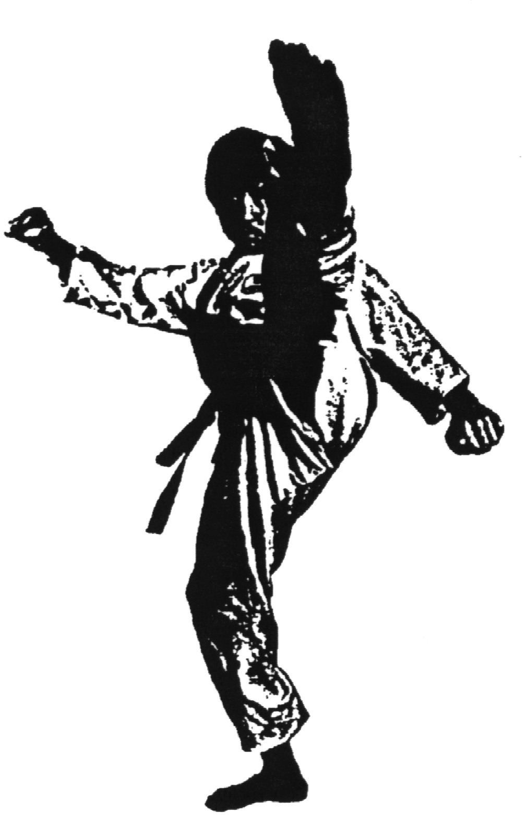

Grand Master Sin Kwang The’

Chinese Shao-Lin Center TENTATIVE Visit Schedule
ALL TESTS: Fridays, 6PM-9PM

- January
- February

- Los Angeles, CA:

Fri. & Sat: February 6th and 7th, 2009
Sat: Shao-Lin Double Daggers – 1st & 2nd Roads
- Phoenix, AZ:
Fri. & Sat: February 20th and 21st, 2009
Sat: Pa Kua Tze Wu Yueh – Pa Kua Sun & Moon Forks
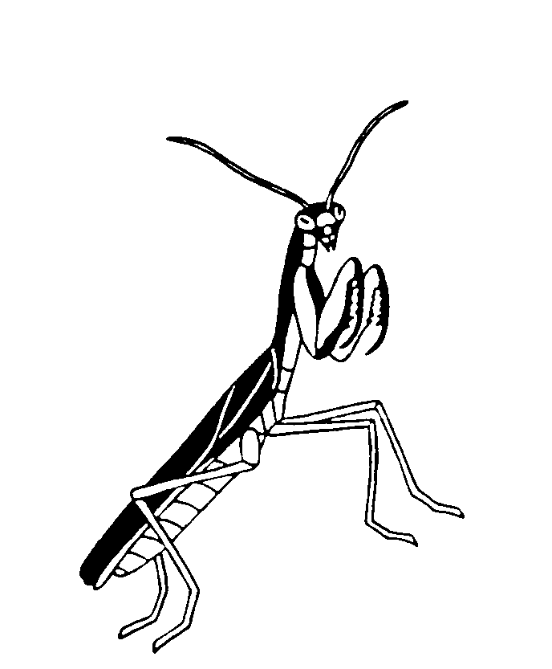
- March
- April

- Albuquerque, NM:
Fri., Sat: May 1st and 2nd, 2009
Sat: Double Mulan Fighting Fans – with “Lightness Training”
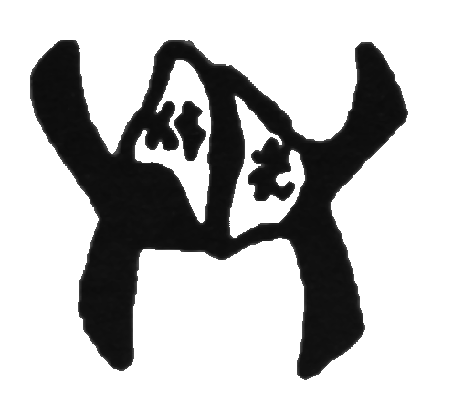
- May

- Boise, ID:
Sat: May 29th and 30th, 2009
Sat: Pa Kua Tao – “High Level” Pa Kua Broadsword Form
- June
- July


- Denver, CO:
Sat & Sun: July 18th and 19th, 2009
Sat: Shao-Lin Ching Pao Chien
Shao-Lin Golden Leopard Fist (3rd & 4th Roads)
Sun: Sr. Black Belt Tests

- August

- September
- October
- November
- December

