CHINESE SHAO-LIN CENTER TENTATIVE CLASS SCHEDULE
2008 | JAN | FEB | MAR | APR | 2008
JANUARY

Brown Belts: Chie’ Chien (Connecting Fist) Shantung Whirling Palms
Black Belts: Endurance Punch & Kick Class

( No Classes Tues., Dec. 18th thru Saturday., Dec. 29th Winter Holiday & New Years! ) Classes Resume WEDS., Jan 2nd, 2008!!!

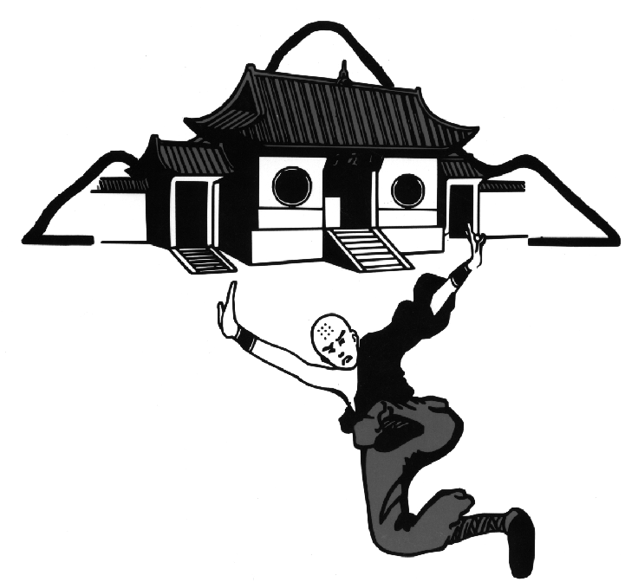
Festivals/Seminars
- IRON BONE TRAINING Starting Sat., Jan. 5th, 9AM - 10AM
(Iron Shin, Iron Forearm, Iron Hand) 1st Blacks & Above, (for 4 weeks!) All CSCs
- YIN/YANG CONDITIONING & Sat., Jan. 12th, 10AM – 2PM
STRETCHING CLASS White Belts & Above, CSC-Denver
( Positive & Negative Training )
- TAI CHI CHUAN Sat., Jan. 26th, 8AM – 4PM
“Classical Yang Family Style” White Belts & Above, CSC-Boulder

Brown Belts: Pai Hao Chuan Tse’ (White Crane Circles It’s Wings) Pai Hao Huan Tse’ (White Crane Flips It’s Wings)

Black Belts: Classical Pa Kua Chang w/ Weight Vest & Forearm Rings

Festivals/Seminars
FEBRUARY
  - HSIEN TIEN CHI Starting Sat., Feb. 2nd, 9AM – 10AM
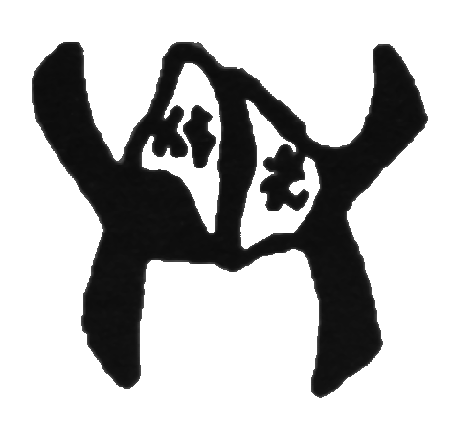
(w/ Hua Tuo Chi Kung / 5 Animal Play) 1st Blacks & Above (for 4 weeks!) CSC- Boulder
- INTRO and THEORY of TIEN HSUI Mon., Feb. 4th, 6PM – 8PM
and 18 HIT the BronzeMan form 5th Blacks & Above , CSC-Boulder
  - TECHNICAL PUNCHING Saturday, Feb. 16th, 10AM – 2PM,
& KICKING CLASS White Belts & Above, CSC-Boulder

“Focus/Snap/Power”
MARCH
Brown Belts: Pai Hao Huan Chiao (White Crane Flips It’s Legs)
Black Belts: Glove Sparring –w/ PaKua footwork & Appl. Gloves/Headgear needed (Sat. CSC-D / Wed. CSC-B)

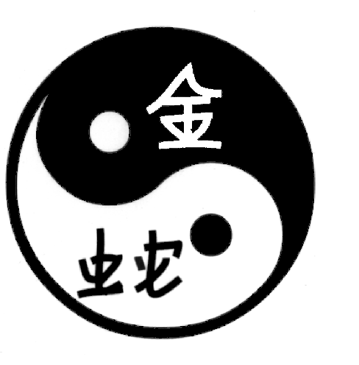
Festivals/Seminars
  - HSING-I 2-PERSON SET Starting Sat., Mar. 1st, 9AM – 10AM
2nd Blacks & Above (for 4 weeks!), CSC- Denver
  - WEAPONS DEFENSE CLASS Saturday, Mar. 8th, 10AM – 2PM,
(Knife, Gun, Stick Defense) White Belts & Above, CSC- Denver
  - SPARRING STRATEGY CLASS Saturday, Mar. 22nd, 10AM – 2PM
(Theory / Concepts / Application) Yellow Belts & Above, CSC- Denver

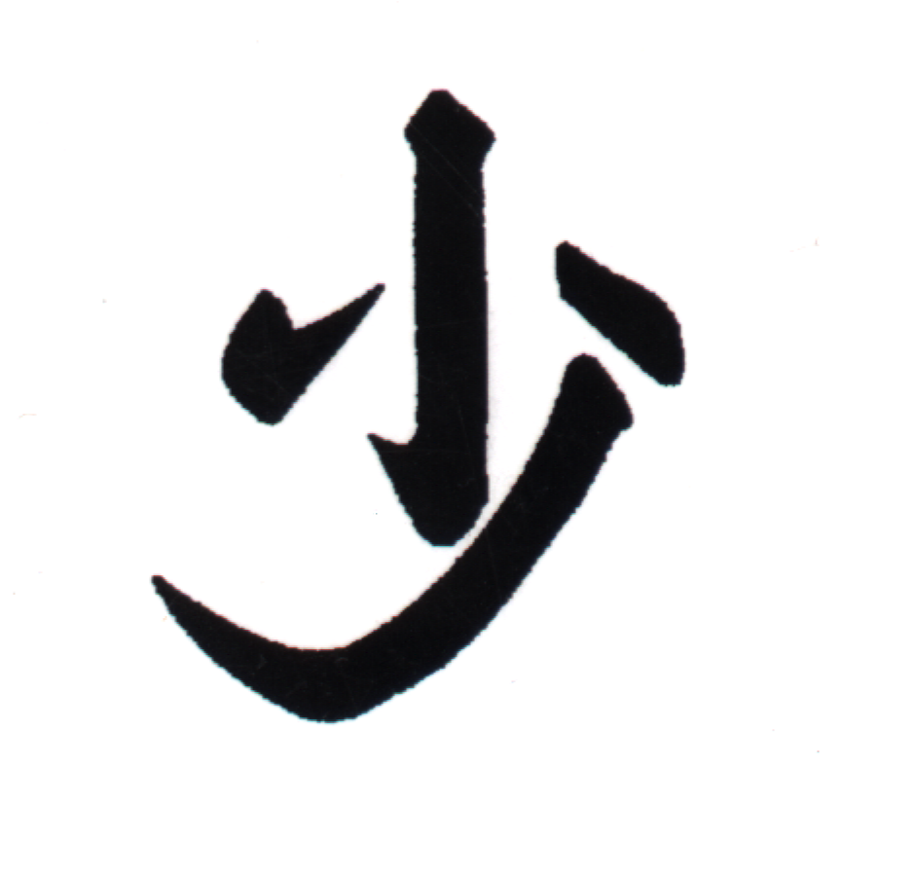
Brown Belts: Ching Kang Fu Hu Chien (Golden Mountain Tiger Form)
Black Belts: Mei Hua Chiang (Plum Blossom Spear)

Festivals/Seminars
APRIL
  - SAN LU HUA CHIEN : BOOK III Starting Sat., April. 5th, 9AM – 10AM
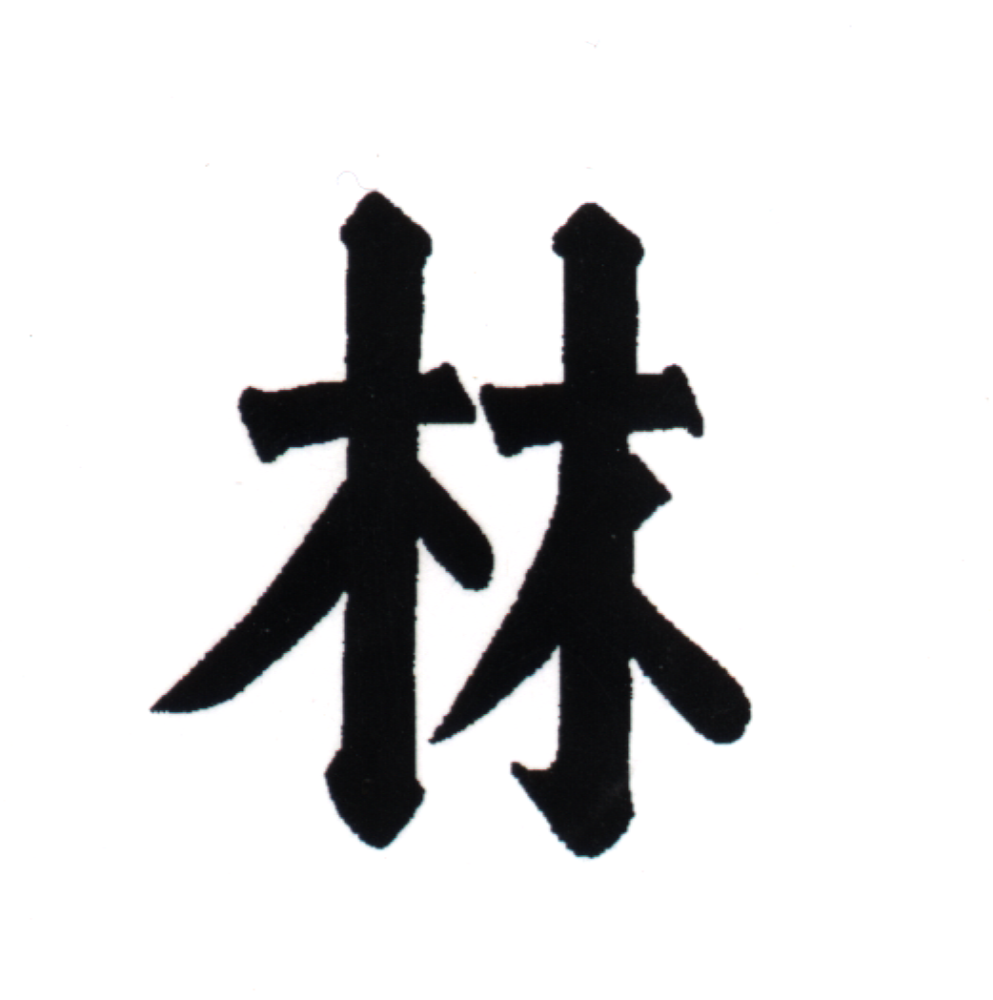
(3rd Road of Hua Mountain Fist) 2nd Blacks & Above (for 4 weeks!) CSC-Boulder
- SUANG CHUE KUAI Mon.., April 7th, 6PM – 8PM
Double ChopSticks form 5th Blacks & Above , CSC-Boulder
  - BROWN BELT PRETEST Thursday, April 10th, 7PM – 10PM, CSC - D / B / CSpgs
(Black Belt Panel Required)
  - I CHIN CHING/SAN HE’ CHIEN Saturday, April 19th, 10AM – 2PM,
(Ta Mo’s Chi Kung/Iron Monk Training) White Belts & Above CSC- Boulder
  - BLACK BELT PRETEST Sun., April 20th, 8AM – 12Noon

Part II (Senior Black Belt Panel Required) CSC-Boulder
  - BROWN BELT TEST Sun., April 20th, 1PM – 5PM
(Black Belt Panel Required) CSC-Boulder
  - YING JOW NA Saturday, May 3rd, 10AM – 2PM,
( Classical Eagle Claw Form ) White Belts & Above, CSC-DENVER- PARK

www.Shao-Lin.Com

