CHINESE SHAO-LIN CENTER TENTATIVE CLASS SCHEDULE
2007 | SEPT | OCT | NOV | DEC | 2007
Brown Belts: Luo Tien / Chan Ie (Descends from Heaven/Spreading of the Wings)
Black Belts: Outdoor Conditioning 8am-10am (Sats. in the PARK) Tai Chi Blindfolded Sparring (Weds)
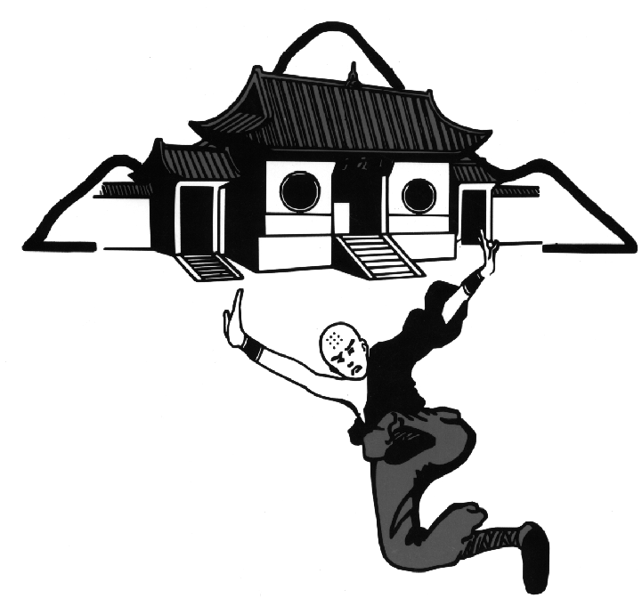
( No Classes Sat., September 1st , Labor Day Weekend! )

Festivals/Seminars
November OCTOBERSEPTEMBER
  - I CHIN CHING/SAN HE’ CHIEN Sat., Sept. 8th, 10AM – 4PM
(Ta Mo’s 49 Chi Kung/Iron Monk Form) White Belts & Above, CSC-Denver
  - TAO vs CHIANG Sat., Sept. 22nd, 10AM – 2PM; CSC-Park @ Denver
“Broadsword vs Spear-2 Person fighting set” Yellow Belts & Above

Black Belt Outdoor Conditioning Class on Sept. 22nd to be held ONLY @ CSC-Denver Park, 8-10AM

REQUIRED INSTRUCTOR TRAINING SEMINAR @ ALBUQUERQUE-
Festival – Sat., Sept. 29th 1PM – 8PM GROUND MONKEY-“1st & 2nd Roads”
( CSC Instructors - Arrive Thurs. 9/27, AM & Depart Tues.10/2, AM )

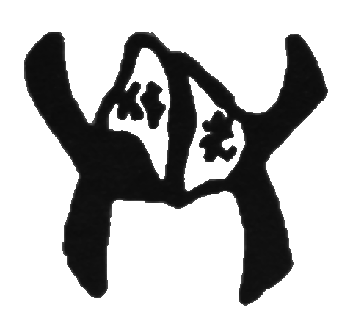
Brown Belts: Yen He’(Performing Swallow)
Black Belts: Hei Hu Huan Sen (Black Tiger Flips its Body)
Festivals/Seminars
  - CHEN TAI CHI CHUAN – Sat., Oct. 6th, 8AM – 8PM

SIN CHIA SE T’AI CH’I CH’UAN PA SE SAN SE
Old House 9th Generation Chen T’ai Ch’i Ch’uan Original 83 Posture Form WHITE Belts & Above, CSC-Boulder

- DBL. TAMO CANES Fighting Form Sat., Oct. 27th, 2PM – 8PM; CSC-PHOENIX
“the Crutches of War” Weapon Festival White Belts & Above

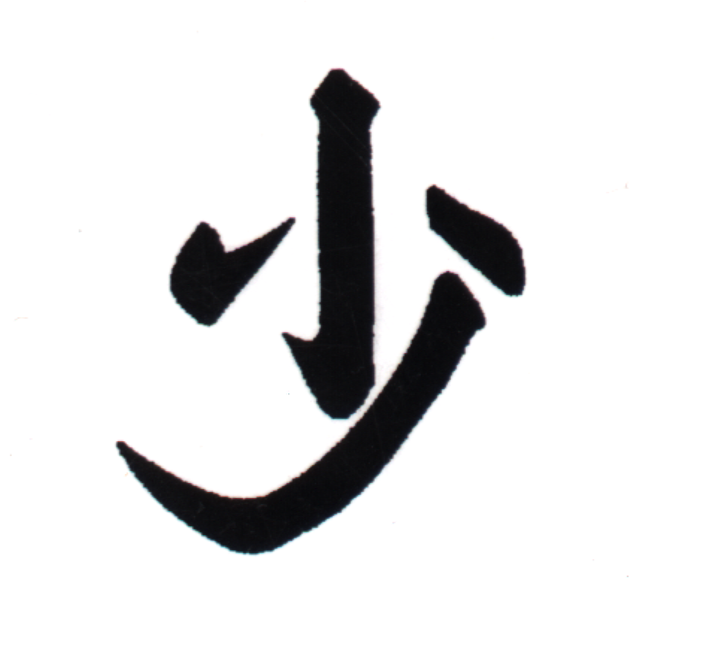
Brown Belts: Lien U Chang (5 Directional Palm) Shantung Whirling Palms Fighting System
Black Belts: Hei Hu Shou Sang (Black Tiger Wounded)

Festivals/Seminars

  - Classical SHAO-LIN U HSING CHUAN Saturday, November 17th, 8AM – 8PM; CSC-Denver
“Traditional 128 Posture 5 Animal Form” White Belts & Above

(No Classes Thurs., Nov.22nd & Sat., Nov. 24th – Thanksgiving Holiday!)

Brown Belts: T’ie Cha (Iron Ruler – Sai)
Black Belts: Classical Pa Kua Chang w/ Weight Vest & Iron Rings (8 Changes of the Palm)
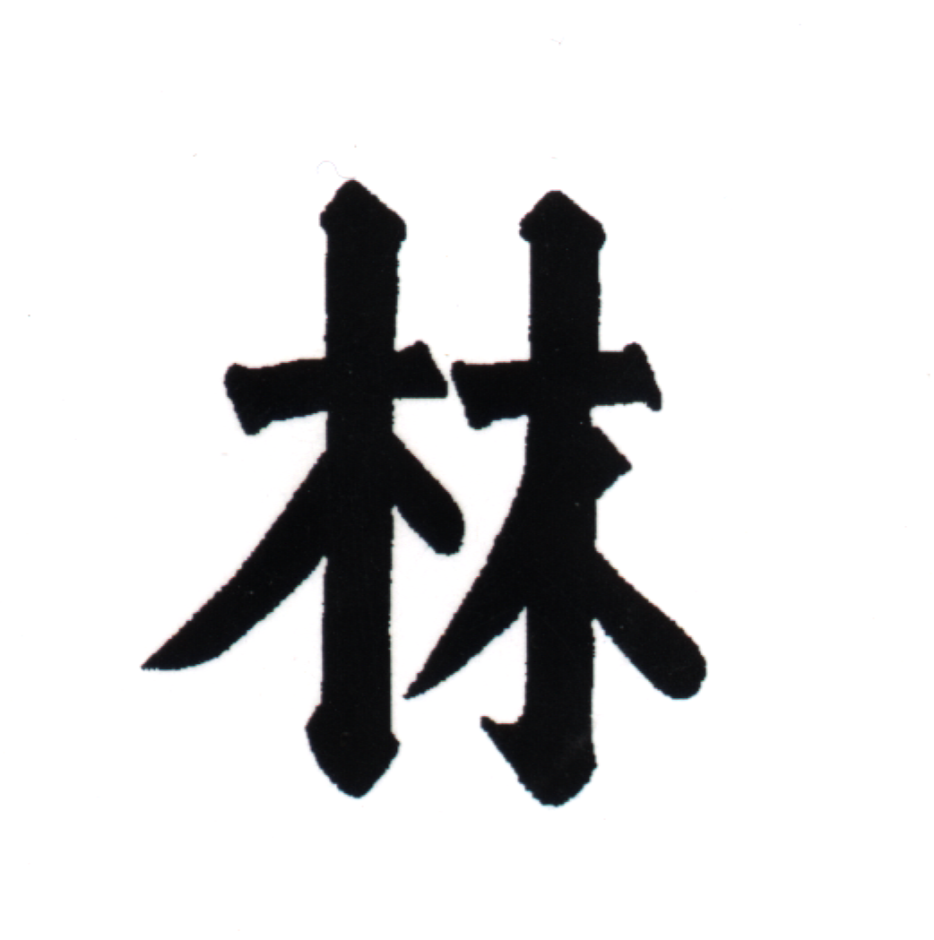
During the Month of December- 10% OFF ALL Sales - 15% of ALL Proceeds towards Charity!
DECEMBER

Festivals/Seminars
  - HSING-I SHUR AR HSING Starting Sat., Dec. 1st , 9AM – 10AM; CSC-Boulder
“Dynamic 12 Animal Internal Boxing” 2nd Blacks & Above (for 3 weeks!)
  - HOU TIEN CHI / MARROW WASHING Sat., Dec. 1ST , 10AM – 4PM; CSC-Boulder
“Chan (Zen) Meditation & Breathing Tech. / Chi Kung Training” White Belts & Above

  - BROWN BELT PRETEST THURSDAY, Dec. 6th, 7PM – 10PM; CSC – Denver/Boulder/Colo. Springs
(Black Belt Panel Required) (Regularly scheduled Brown Belt Classes pre-empted this evening!!)

  - BLACK BELT PRETEST Sun., Dec. 16th , 8AM–12Noon;CSC – Boulder (Senior Black Belt Panel Required)

  - BROWN BELT TEST Sun., Dec. 16th , 1PM – 6PM; CSC – Boulder (Black Belt Panel Required)

( No Classes Tues., Dec. 18th THRU Sat., Dec. 29th – Winter Holiday & New Years / Classes resume Weds., Jan.2nd , 2008 )

