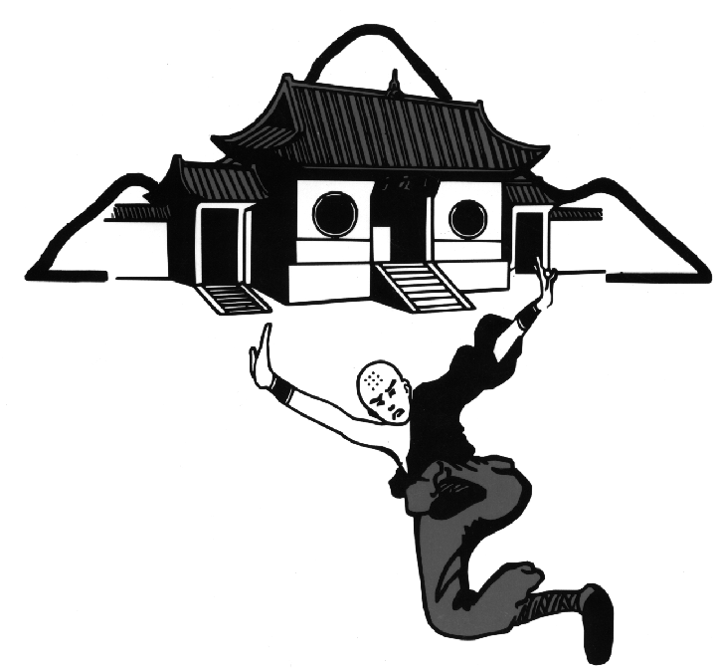
CHINESE SHAO-LIN CENTER TENTATIVE CLASS SCHEDULE
2005 | SEPT | OCT | NOV | DEC | 2005
Brown Belts: Luo Tien / Chan Ie (Descends from Heaven/Spreading of the Wings)
November OCTOBERSEPTEMBER
Black Belts: Outdoor Conditioning (Sats. in the PARK)
Tai Chi Blindfolded Sparring (Weds)
( No Classes Sat., September 3rd , Labor Day Weekend! )

Festivals/Seminars

  - YIN PI SHOU CHIEN Sun., Sept. 11th, 10AM – 2PM;
O-Mei “White Eyebrow Monk’s” Sgl Dagger Set White Belts & Above, CSC-Boulder
- YANG PI SHOU CHIEN Sat., Sept. 24th , 10AM-2PM
O-Mei “White Eyebrow Monk’s” Sgl Dagger Set White Belts & Above, CSC-DENVER

Brown Belts: Yen He’(Performing Swallow)
Black Belts: Hei Hu Huan Sen (Black Tiger Flips its Body)
Festivals/Seminars
  - HSIANG CHUNG LI – The Stomping Immortal – Starting Sat., Oct. 8th, 9AM – 10AM (for 4 weeks!)
“Pa Hsien-8 Immortals” 1st Blacks & Above, CSC-Boulder, Boise , Phoenix

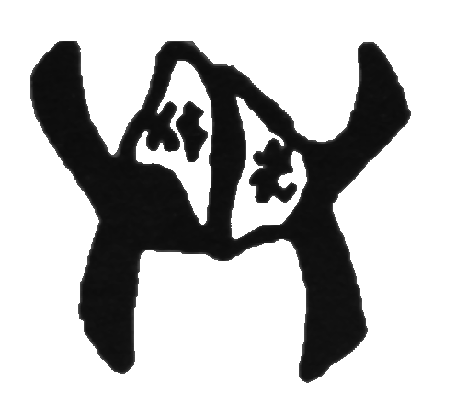
- TAI CHI SAN Sun., Oct. 9th, 10AM – 4PM; CSC-Denver
“Chen style Iron Fan” White Belts & Above

  - I CHIN CHING / SAN HE’ CHIEN Sat., Oct. 22nd , 10AM – 4PM; CSC-Boulder
“Ta Mo’s Muscle Tendon Change Classic” White Belts & Above

Brown Belts: Lien U Chang (5 Directional Palm) Shantung Whirling Palm Fighting System
Black Belts: Hei Hu Shou Sang (Black Tiger Wounded)

REQUIRED INSTRUCTOR TRAINING SEMINAR @ Phoenix ( Arrive Thurs. 11/3, AM & Depart Tues.11/8, AM )

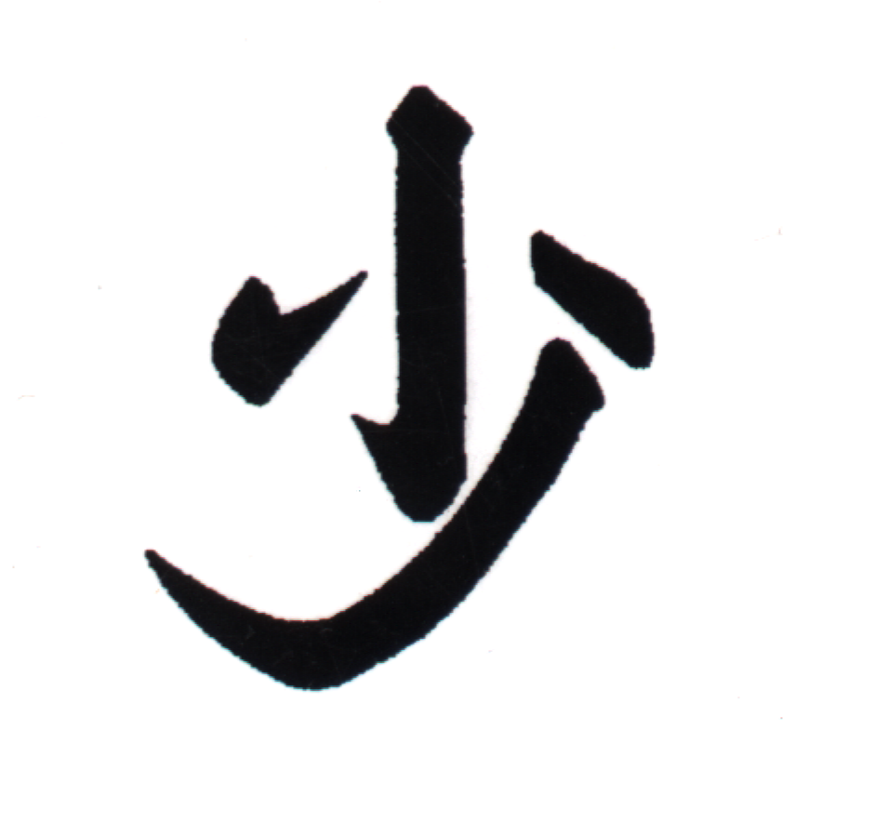
Festivals/Seminars
- ER LU HUA CHIEN – Book II Sat. Nov. 12th , 8AM-10AM; (for 2 weeks!)
“2nd Road of Hua Mtn. Fist” 2nd Blacks & Above CSC-DENVER

  - TECHNICAL PUNCH/KICK CLASS SAT., Nov. 19th, 10AM – 2PM; CSC-Denver
“Develop Focus/Snap/Power” Yellow Belts & Above

(No Classes Thurs., Nov.24th & Sat., Nov. 26th – Thanksgiving Holiday!)

Brown Belts: T’ie Cha (Iron Ruler – Sai)
Black Belts: Classical Pa Kua Chang w/ Weight Vest & Iron Rings (8 Changes of the Palm)
During the Month of December- 10% OFF ALL Sales - 20% of ALL Proceeds towards Charity!
DECEMBER

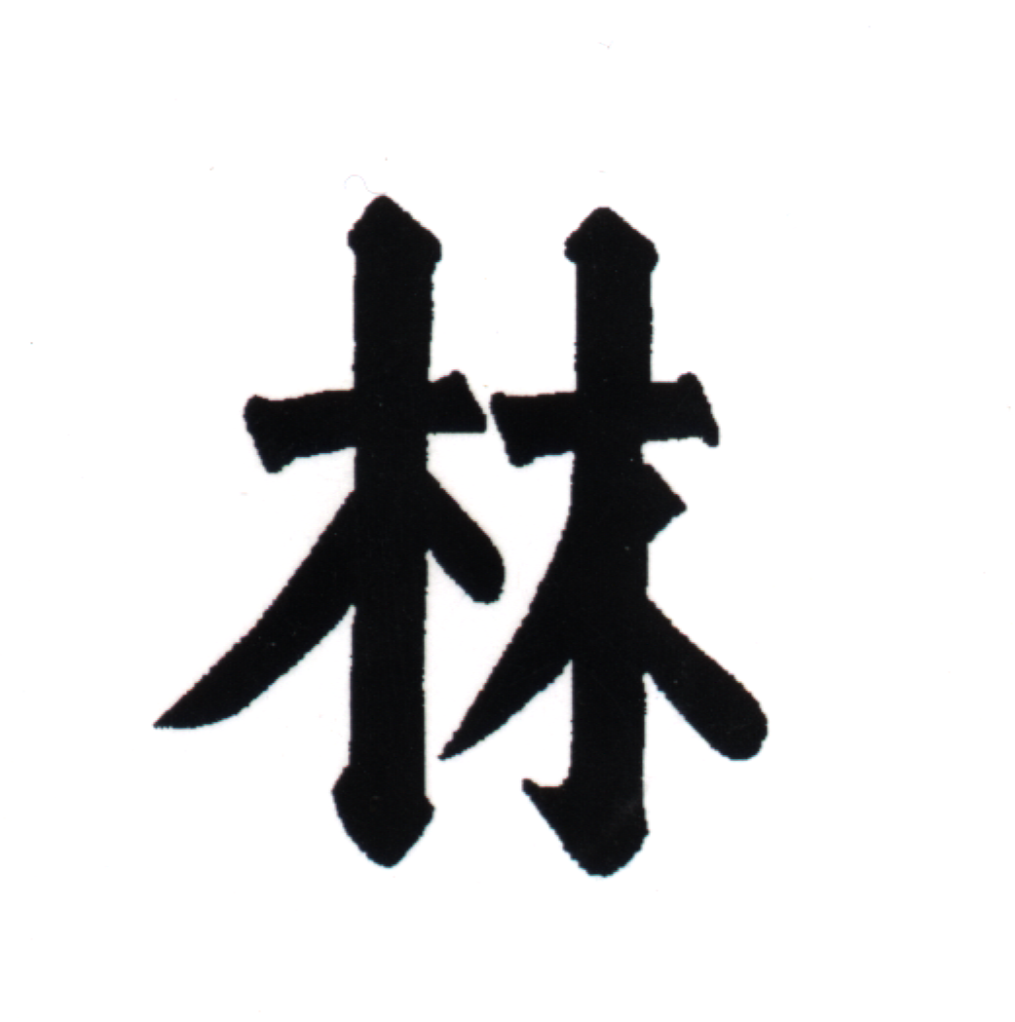
Festivals/Seminars
  - HSING-I SHUR AR HSING Starting Sat., Dec. 3rd , 9AM – 10AM; CSC-Boulder
“Dynamic 12 Animal Internal Boxing” 2nd Blacks & Above (for 3 weeks!)
  - HOU TIEN CHI / MARROW WASHING Sun., Dec. 4th , 10AM – 4PM; CSC-Boulder
“Chan (Zen) Meditation & Breathing Tech. / Chi Kung Training” White Belts & Above

  - BROWN BELT PRETEST Sat., Dec. 10th, 2PM – 6PM; CSC – Denver/Boulder/Colo. Springs
(Black Belt Panel Required)

  - BLACK BELT PRETEST Sun., Dec. 18th , 8AM–12Noon;CSC – Boulder (Senior Black Belt Panel Required)

  - BROWN BELT TEST Sun., Dec. 18th , 12NOON – 6PM; CSC – Boulder (Black Belt Panel Required)

( No Classes Tues., Dec. 20th THRU Sat., Dec 31st – Winter Holiday & New Years / Classes resume Tues., Jan. 3rd , 2006 )

